**AWS Learning Material**

Free Courses By AWS : <https://aws.amazon.com/certification/certified-cloud-practitioner/#:~:text=The%20AWS%20Certified%20Cloud%20Practitioner,for%20basic%20AWS%20Cloud%20fluency.>

Enrolled Courses to see: <https://explore.skillbuilder.aws/learn/mycourses>

**Exam Details**

The Exam consists of 65 multiple-choice questions. The Exam is time-limited to 90 minutes. Candidates must have 70% correct answers to pass the Exam and become certified. Unanswered questions count as incorrect. Always answer, even if you are guessing. You can go back and review questions. Immediately after completing the Exam, you will be informed of your score and of your pass/fail status

|  |  |
| --- | --- |
| **Subject** | **Weight** |
| Cloud Concepts | 26% |
| Security and Compliance | 25% |
| Technology | 33% |
| Billing and Pricing | 16% |
| **Total** | **100%** |

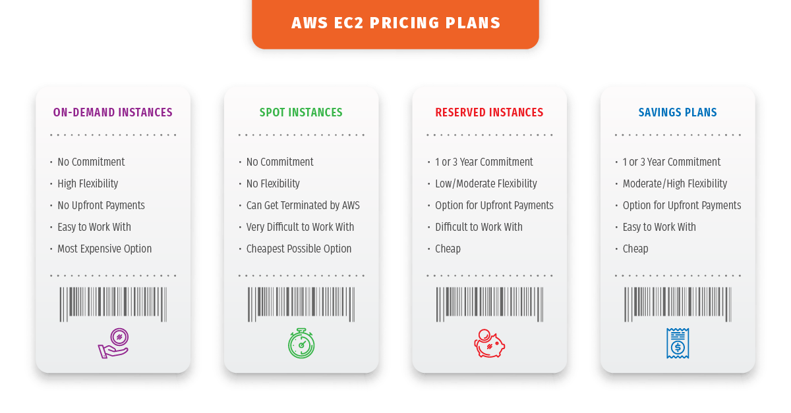

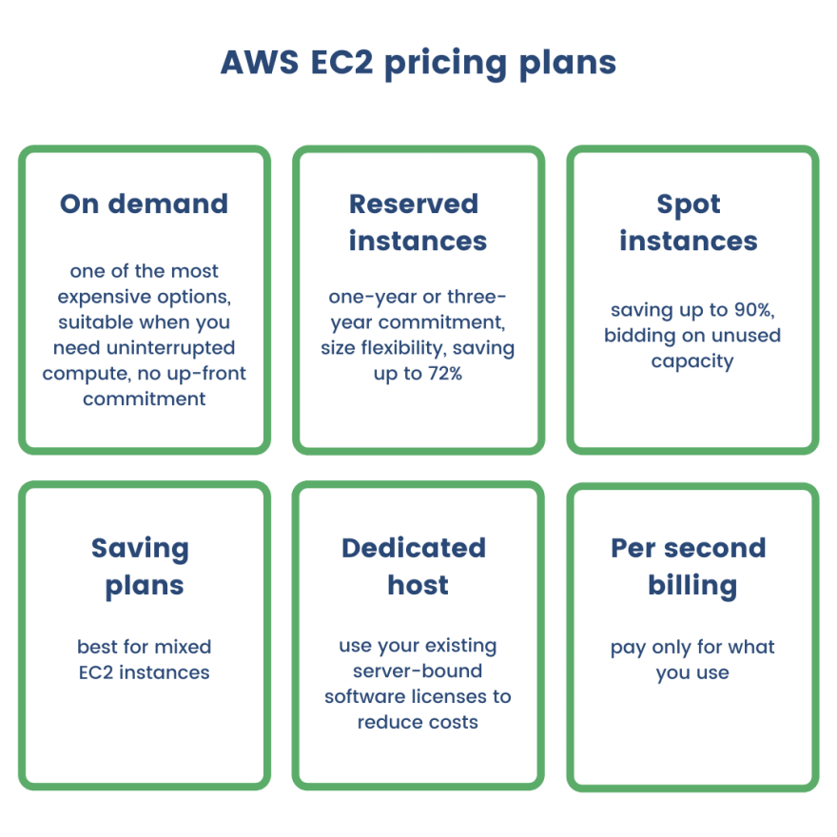

**On Demand:**